**Draft Proposal for the PG Project**

Project Title: Salik SmartRewards – A Robotic Reward Redemption System for Toll Users.

*Objective*:

To design and implement a compact, interactive robotic kiosk that enables Salik toll users to redeem loyalty points via an iPad-based interface. The system integrates software (QR scanning, authentication logic) with hardware (fingerprint sensor, servo dispenser), simulating a real-world rewards redemption workflow based on toll usage.

*Background and Motivation – Problem Statement:*

Despite the widespread adoption of Dubai’s Salik toll system for automated road charging, regular commuters face growing frustration due to increased toll tariffs and a lack of incentive for frequent usage. Currently, Salik operates as a purely transactional platform with no built-in rewards or user engagement mechanisms, which can lead to user dissatisfaction and disengagement.

In an era where smart infrastructure and user-centric design are key components of public service innovation, there is a clear gap in how toll systems can evolve beyond revenue collection to provide value-added experiences. While loyalty programs are common in other sectors, they are rarely applied to transportation toll systems in an interactive, tech-driven manner.

This project aims to address that gap by developing a robotics-integrated rewards redemption kiosk that allows users to redeem points earned through toll usage. The system will incorporate QR-based authentication, fingerprint verification, emotional feedback through facial recognition, and LED-guided interaction, creating a secure, intelligent, and emotionally responsive user experience.

*Proposed System Description:*

The project consists of a robotic kiosk prototype that:

1. The user logs in to the iPad/Android app with their username.
2. The app fetches the user's point balance (simulated via a local CSV file).
3. The user is prompted to scan a QR code (using the iPad/Android's rear camera).
4. If valid and eligible, the user is asked to authenticate with a fingerprint (via the R307 module connected to Arduino).
5. Upon a successful match, Arduino activates a servo motor to dispense a reward.
6. The system logs the transaction in a local CSV file.

*Key Components:*

Software:

* iPad/Android App GUI: Built using Swift or Flutter (TBD) for a user-friendly interface
* QR Code Scanning: Handled via iPad/Android camera
* Python Backend: Manages user data, QR payload generation, and logging (optional if all logic is embedded in the app)
* CSV Simulation: Stores user toll crossings and points data

Hardware:

* Arduino Uno: Controls the fingerprint module and servo motor
* R307 Fingerprint Sensor: For biometric authentication
* Servo Motor: Physically dispenses reward (e.g., token, voucher)
* Serial Communication: Between iPad/Android app and Arduino via USB or Bluetooth (TBD)

*Sample Design:*

* 1. Amazon

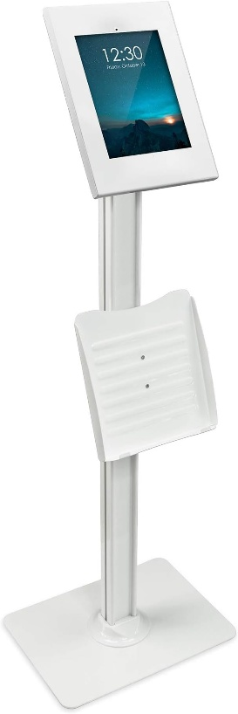

Camera for QR code reading



Voucher Dispenser

Fingerprint Module

iPad/Android Display



* 1. Sketch

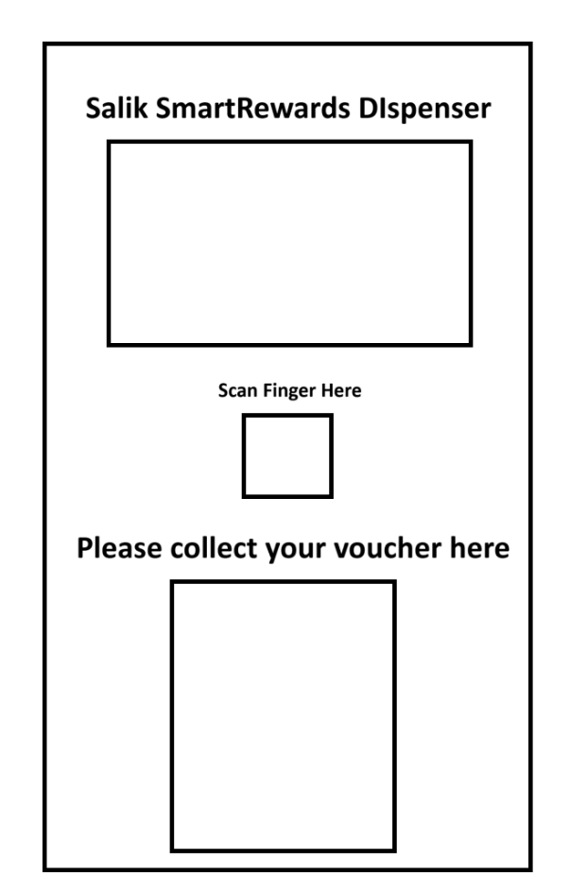

Box

Dispenser

Fingerprint Reader

User Interface

*Enhancing Robotics Scope:*  
To strengthen the robotics foundation of this project, the following intelligent, hardware-integrated features have been added to expand real-world interaction, adaptive behavior, and robotic expressiveness:

1. LED-Based Interaction Mapping

A multicolor LED system will guide the user through the redemption process:

* 🔵 Blue: Scanning QR
* 🟡 Yellow: Awaiting fingerprint
* 🟢 Green: Successful authentication
* 🔴 Red: Error or invalid entry

This improves usability while mimicking robotic state feedback, similar to human-robot interaction cues in autonomous systems.

2. Emotion Detection + Adaptive Voice Feedback

Using the iPad camera or an external webcam (TBD), the system detects the user's emotional state (e.g., happy, neutral, frustrated) using a lightweight ML. Based on this, personalized voice messages are delivered using offline text-to-speech or pre-recorded responses.

This brings in elements of robot perception and reactive engagement, elevating the system beyond static logic into the realm of emotionally aware robotic design.